St. Anthony’s Weekly Message
For Sunday August 29, 2021

Topics: Prayers for Afghanistan, When to Follow and When to Lead, Photos of St. Anthony’s Religious Ed. “Fun Afternoon,” Beginning Date of This School Year’s St. Anthony’s Religious Ed. Program, and Pre-ordering for the Curbside Event September Italian Dinner

(Moses)

https://www.google.com/search?q=Moses+and+his+people&client=firefox-b-1-d&source=lnms&tbm=isch&sa=X&ved=2ahUKEwjDiMOXxNHyAhWCbs0KHeadA-8Q_AUoAXoECAEQAw&biw=2144&bih=1004#imgrc=G_PQEUIz3iZW9M&imgdii=a66F1HAimGoHMM

Dear St. Anthony’s Religious Ed. Families, Parishioners and Friends,

This has been a week of joy locally and enormous sadness on the world stage. St. Anthony’s children, teens, parents, and religious education staff had a wonderful time at our “Fun Afternoon” this past Tuesday, as our photos will demonstrate. However, anyone who has paid attention to the world news realizes the tragedy of the situation in Afghanistan. It is important to give all of life’s experiences due importance. We must remember to be grateful for the good things God sends our way and also seek God’s assistance, while doing our part, when times are hard.
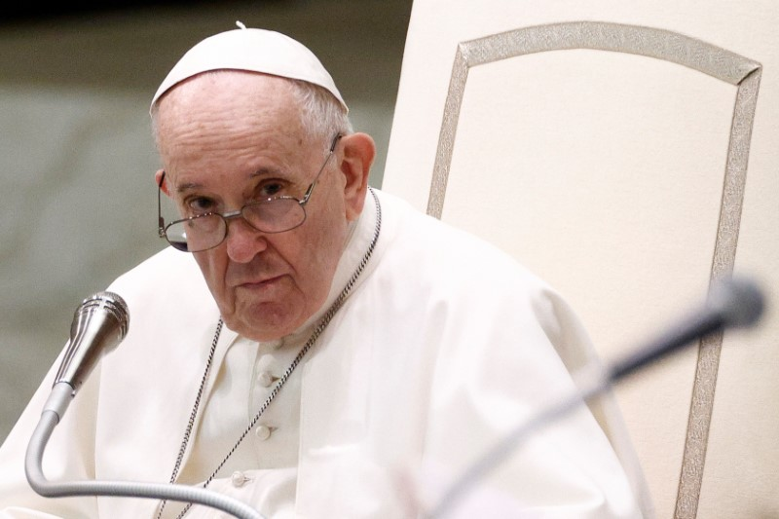
Prayers for Afghanistan

On August 15, Our Holy Father Pope Francis asked for prayers for Afghanistan: “I join in the unanimous concern for the situation in Afghanistan. I ask all of you to pray with me to the God of peace, so that the clamor of weapons might cease and solutions can be found at the table of dialogue.” https://www.catholicweekly.com.au/pope-asks-for-prayers-for-afghanistan/
The Vatican News also ran an appeal from a Catholic Barnabite priest and missionary living in Afghanistan:
Barnabite Fr. Giovanni Scalese, head of Missio sui iuris, serves by offering a Catholic presence in the Asian country. He urges everyone to draw close spiritually to the people and pray that the Lord may save Afghanistan from more suffering and bring them lasting peace, and says, “ ‘We are living days of great apprehension as we await what happens. My appeal to the listeners of Vatican Radio is to pray...pray, pray, pray for Afghanistan! Thank you.’ ” https://www.vaticannews.va/en/church/news/2021-08/barnabite-missionary-appeal-pray-pray-pray-for-afghanistan.html
We at St. Anthony’s pray for peace and the safety of the people of Afghanistan and for the delivery from harm of all seeking to leave, including both Americans and Afghans. We pray that all those fleeing from persecution will find safe havens and loving support.

This Week’s Readings, Showing When and Whom to Follow and When to Lead

Sunday Mass Readings for August 29 2021, Twenty-second Sunday in Ordinary Time, Year B
1st Reading | Deuteronomy 4:1-2, 6-8
Responsorial Psalm | Psalms 15:2-3, 3-4, 4-5
2nd Reading | James 1:17-18, 21B-22, 27
Alleluia | James 1:18
Gospel | Mark 7:1-8, 14-15, 21-23

In our first reading from Deuteronomy and our second reading from James, the message is similar. God’s law is eternal. It applies to the past, present, and future. Whatever the popular culture of a time or place, loyal followers of God do not let themselves be swayed away from the right path:

From Deuteronomy:
In your observance of the commandments of the LORD, your God, which I enjoin upon you, you shall not add to what I command you nor subtract from it.

From James:
Dearest brothers and sisters:
¹⁷ All good giving and every perfect gift is from above, coming down from the Father of lights, with whom there is no alteration or shadow caused by change.

While true Christians are followers of God’s way, they should also be leaders to their fellow humans by being good examples:

From Deuteronomy:

⁶ Observe them [God’s laws] carefully, for thus will you give evidence of your wisdom and intelligence to the nations, who will hear of all these statutes and say, ‘This great nation is truly a wise and intelligent people.’
¹⁸ He willed to give us birth by the word of truth that we may be a kind of first fruits of his creatures.
²¹ Humbly welcome the word that has been planted in you and is able to save your souls.
²² Be doers of the word and not hearers only, deluding yourselves.
²⁷ Religion that is pure and undefiled before God and the Father is this: to care for orphans and widows in their affliction and to keep oneself unstained by the world.

People in the United States and all around the world today face situations that could pull them away from God. Advertising, films, television, and social media offer examples of self-centered, unbelieving people who live for their own pleasure. In real life, young people may face ridicule from unbelieving peers. Instead of being “one of the crowd,” blindly following these negative examples, Christians of all ages can shine as leaders, happy and enjoying life as followers of God.

Photos from St. Anthony’s August 24th Fun Afternoon

Children and teens of ages four to fifteen enjoyed themselves at St. Anthony’s Religious Education “Fun Afternoon” on August 24th. Indoor activities included a variety of crafts, games like Hedbanz, “duck pond” prizes, and trivia contests for youngsters and parents. Outdoors, the large church lawns provided lots of space for corn hole, horse shoes, bocce, and spoon relays. St. Anthony’s Religious Education/Youth Ministry program plans to hold more fun fellowship activities during the upcoming school year.
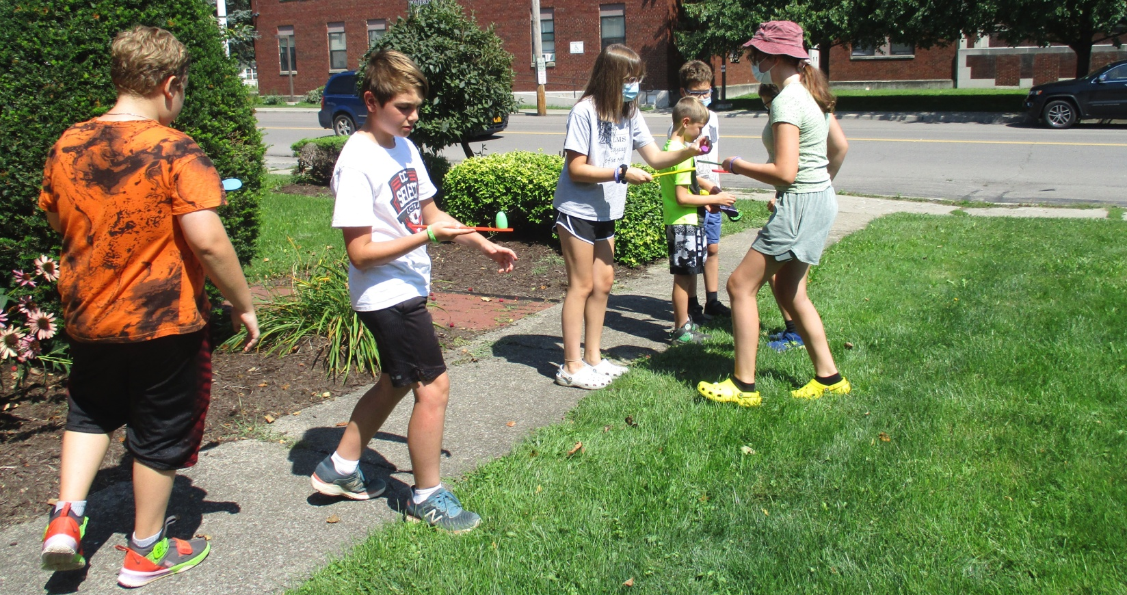

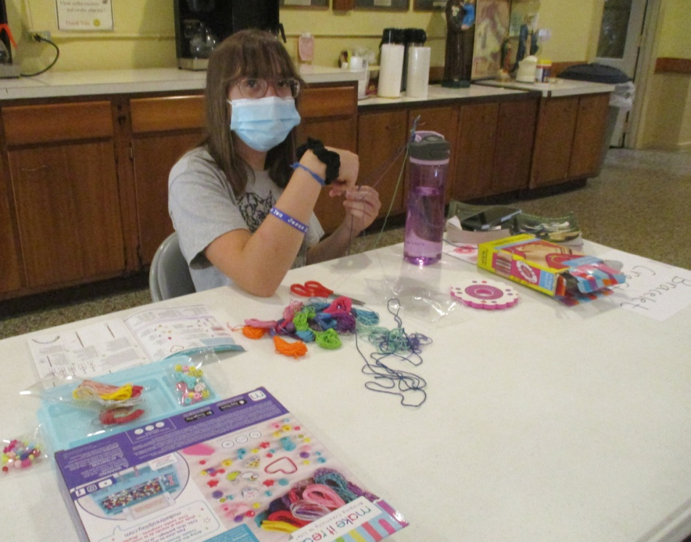

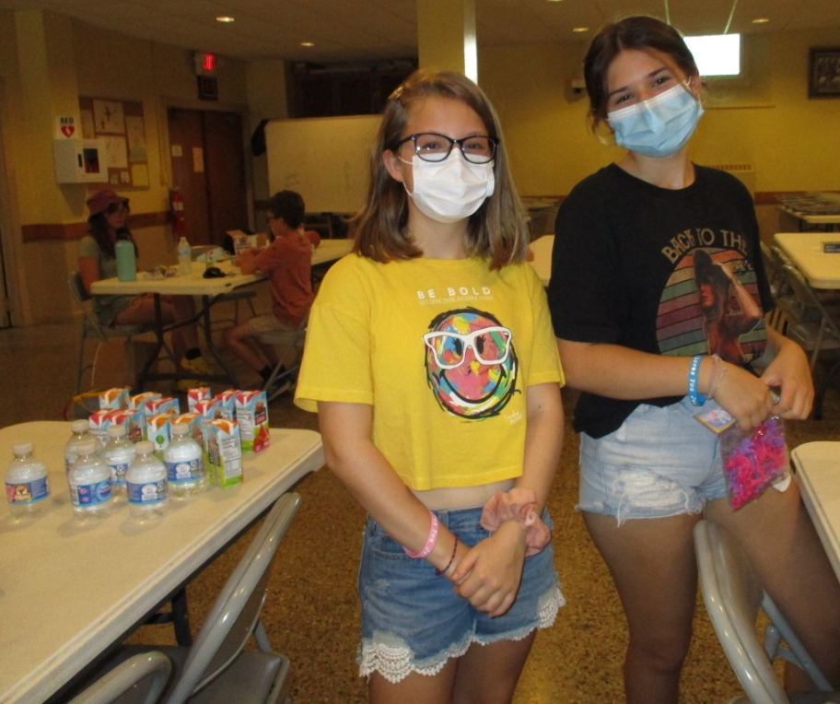

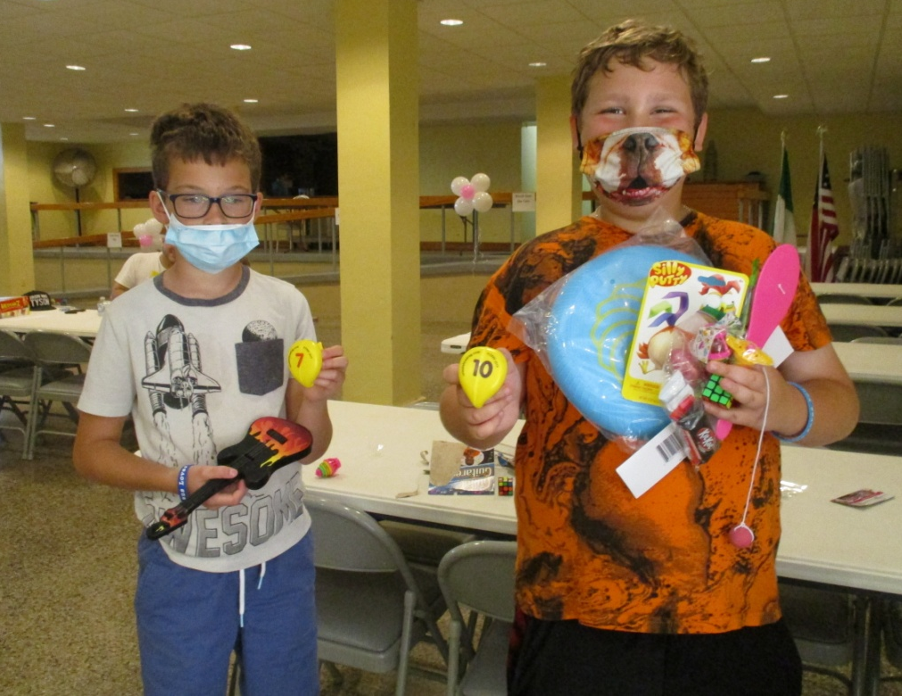

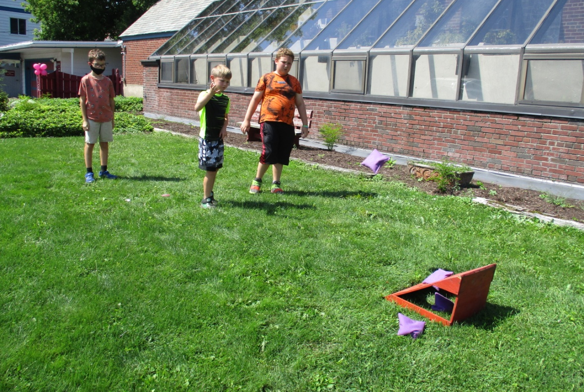

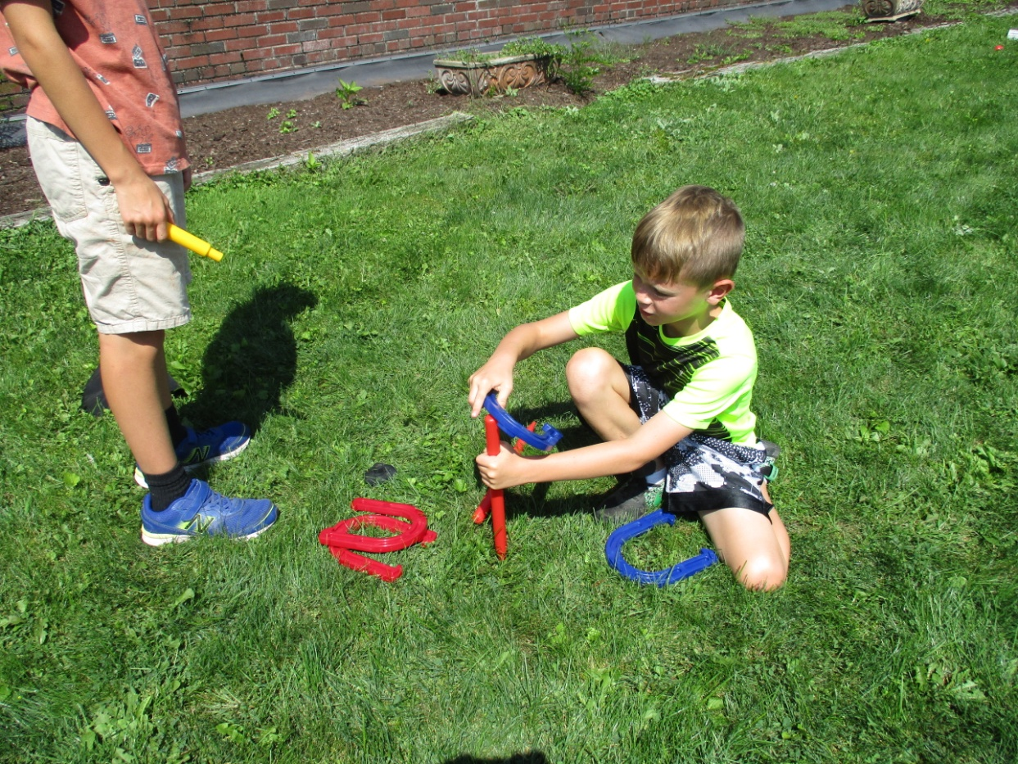

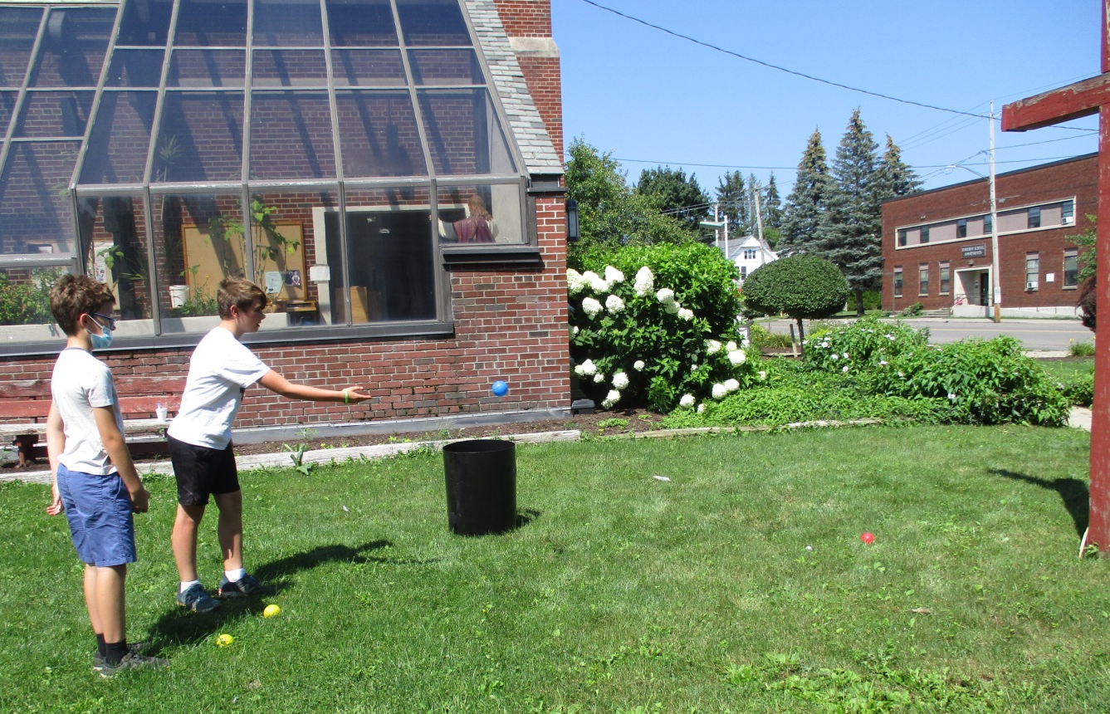

St. Anthony Religious Education/Youth Ministry Begins Sept. 19th at St. Anthony’s!

St. Anthony’s program includes both traditional weekly religious education classes and youth ministry activities for all ages at different times throughout the year. Our classes provide interactive, age appropriate religious instruction. This coming school year’s classes, from pre-k to high school, will begin on Sept. 19th. Classes take place in St. Anthony’s Church Hall and St. Anthony’s Rectory from 10:45 to 11:45. Students may attend in person or virtually via Google Classroom.

St. Anthony’s Youth Ministry has fun fellowship activities that take place at St. Anthony’s Church or in the community, such as our miniature golf event. Dates for youth ministry activities will be posted in advance. Some activities will be for younger students, some for older ones, and some for all students and even parents. We are eager to see new and continuing students this fall!

St. Anthony’s September Curbside Take-Out, Pre-Order Dinner Sept. 9

Our last curbside event is a complete Italian dinner. It must be pre-ordered by Sept. 7. This is a dinner event. Food must be picked up between 4 PM- 6 PM. Enjoy this delicious dinner!

Here are the details:

St. Anthony’s Festival: Curbside Event 2021 SAT. SEPT 11th / NOTE TIME: 4pm-6pm!
Grand Finale Dinner: Italian Wedding Soup, Salad, Bread, Entree featuring 2 Lasagna roll-ups with Meat Sauce, Oven-Roasted Chicken, and Italian Cookies for Dessert. Sorry, no special orders. $15.00 per order. Cash Only!
PRE-ORDER ONLY! Now thru Sept 7th
To place your order call: Cindy: 607-753-8948 Judy: 607-591-4195 Phil: 607-753-7826 Annamaria: 607-745-0834
THIS IS A DRIVE THRU EVENT. St. Anthony’s Church Parking Lot / 50 Pomeroy Street, Cortland, NY ALL PROCEEDS BENEFIT ST. ANTHONY’S PARISH AND OUR MANY MINISTRIES

Enjoy the great summer weather next week!

Blessings,

Stephanie Passeri-Densmore and Bob Densmore (Coordinators of St. Anthony’s Religious Ed.)
607 756-6723

